Rocketry Notes
Christopher Kalitin

Sep 16 2025 - Scrintle Injector

Scrintle Injector

https://www.halfcatrocketry.com/thrust-chamber-assembly

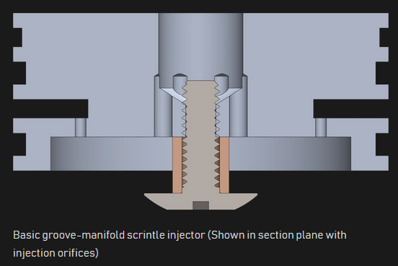

Groove-manifold:
You make a manifold (an internal chamber) and machine a groove into it. The groove serves as an orifice.

A manifold is machined radially into the injector plate. Then, axial groves are machining into the primary injector face. This injects the fuel.

The primary oxidizer inlet in axial (in-line with the axis of the injector). Smaller holes are machined just slightly off the central axis, which serve as orifices for oxidizer to be injected towards a screw-like part which deflects the flow into the radial direction, towards the fuel.

I imagine this leads to relatively low C* since flow isn’t extremely precise and orifices are spaced apart relatively far from each other.

C* = combustion efficiency = ratio of heat released to fuel’s total heating value.

How does injection work when you have high-pressure gas all around you? How does C* change with combustion chamber pressure?

Pressure Transducer

Transducer = a device that converts energy from one form to another. Usually into an electrical signal.

Eg. transforming sound into an electrical signal is a microphone, audio transducer.

Pressure transducers transform pressure into electrical signals.

All sensors are transducers. Sensors are devices that respond to a physical stimulus providing a measurable signal.

Not all transducers are sensors. Eg. a speaker transforms electrical energy into mechanical motion to produce sound. But we don’t call that a sensor because it gives us audio.

Halfcat Liquid Injector Plate

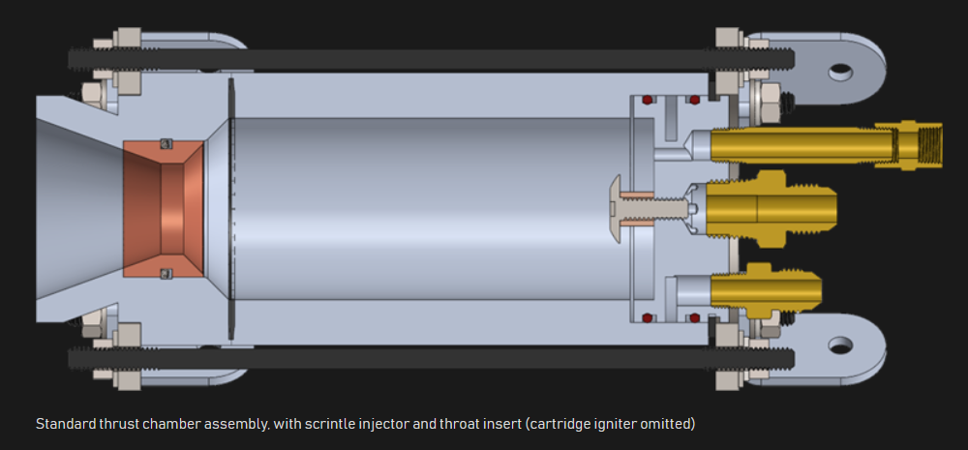

On the left side of the imagine the injector plate is shown, with the in-line oxidizer inlet, off-axis (bottom) fuel inlet, and the off-axis (top) ignitor.

An O-ring is in place between the extruded tube combustion chamber wall and the solid round bar machined nozzle. This O-ring prevents exhaust gasses from exiting radially.

The two O-rings between the injector assembly and the combustion chamber wall prevent exhaust gas exiting on the axis of the motor, out through where the injector hardware sits.

Copper or graphite throat insert increases chamber survivability against longer burns. Copper because it’s a better heat sink?

Copper specific heat capacity: 0.385 J/gC
Copper density: 8.96 g/cm³
Steel specific heat capacity: 0.48 J/gC
Steel density: 7.85 g/cm³

Looks like copper loses slightly in the volume-constant heat sink game. It has higher thermal conductivity so maybe that’s why it wins? The nozzle stays alive slightly longer even though it can sink less heat itself?
Instrumentation would be an extremely fun problem on a liquid rocket engine.

Cartridge Ignitor

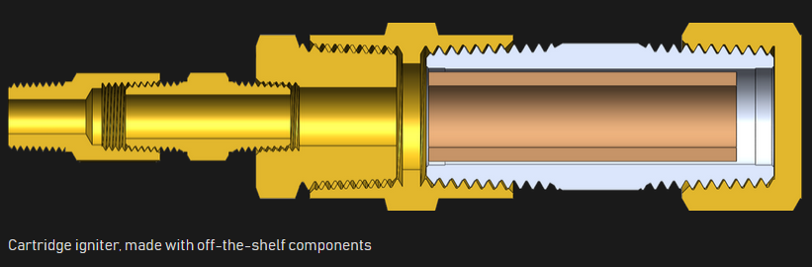
Idk what most of these parts are and why there are so many parts.

The ignitor provides the initial heat to decompose nitrous oxide into nitrogen and oxygen, which then burns with fuel to sustain combustion.

A solid propellant cartridge igniter is used. Usually Estes blackpowder motor.
An ignitor inserted into the throat would be in the liquid propellant stream, the cold propellants could extinguish the igniter flame.

The cartridge ignitor is threaded into the injector instead of the chamber wall for vehicle aero reasons (don’t want it protruding). Slightly difficult to route the ignitor through-hole bitten the central oxidizer port and fuel groove-manifold.

A pressure transducer can be placed with the ignitor since it’s open to the combustion chamber, but is slightly removed from the high heat flux area.

Axial Rods

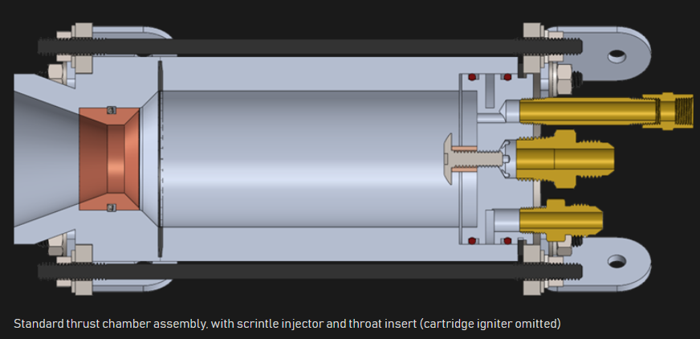

Because only the O-Rings are present as physical contacts between the three primary engine assemblies, axial rods are required to keep everything in place and provide clamping pressure on the O-Rings.

Normal force is what provides the thrust, which is relatively evenly distributed through the combustion chamber (?). It’s present on all surfaces. Probably most present on the injector face, less so on the Nozzle.

This explains why the V2’s H2O2 (Hydrogen Peroxide) gas generator exhaust increased thrust. It reacted with the primary combustion chamber exhaust, increasing pressure in the exhaust flow, which pushes up on the exhaust, back into the nozzle.

https://www.youtube.com/watch?v=r3bwidwct6M

Sep 16 2025 - O-Rings
https://www.marcorubber.com/o-ring-groove-design-considerations.htm

O-Ring squeeze compression = % deformation of the O-ring in the direction normal to the surfaces being brought together.

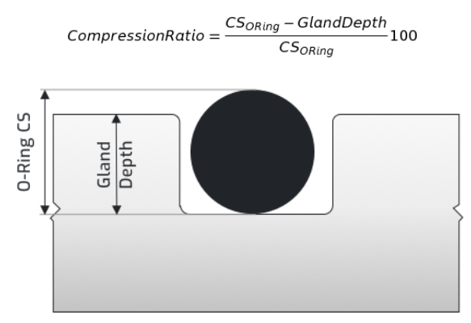

O-Ring Stretch = Original inner-diameter to final inner-diameter.
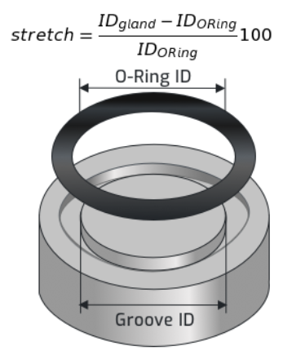

Application Pressure to Ring Gland Clearance Gap Size:

Need to balance clearance gap and pressure exerted on the O-Ring to ensure no extrusion occurs.

Note “application pressure” refers to the pressure of the fluid on the O-Ring, not the clamping pressure.

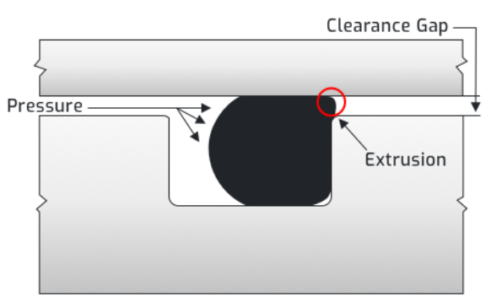

Roughness Average

Roughness Average (Ra), measured in microns. Usually 16-32 to previate abrasion or spiraling.
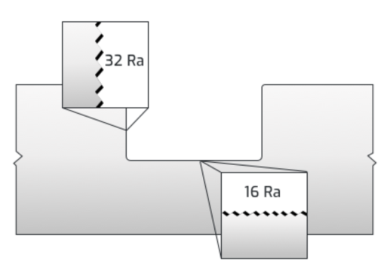

O-Ring Gland Fill

Ratio of O-Ring volume to gland volume.

If gland fill is too high, it can become over-compressed and extrude into the clearance gap.

If the gland fill is too low, O-Ring doesn’t compress adequately and results in an ineffective seal.

Gland = groove / cavity which the O-Ring inhabits.

